FOR IMMEDIATE RELEASE
NOVEMBER 4, 2019

MEDIA CONTACT:
Carrie Pitts-Densmore
919-256-2187
cpittsdensmore@urbanmin.org

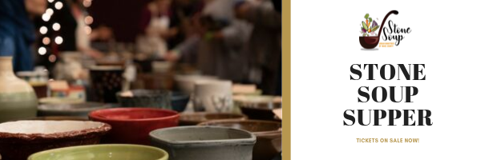

Urban Ministries of Wake County Hosts Annual Stone Soup Supper Presented by Bank of America
Raleigh, NC – If you are a fan of good food and want to give back to your community, don’t miss one of the Triangle’s most popular fundraisers, benefiting Urban Ministries of Wake County. Stone Soup Supper, presented by Bank of America, will feature 15 local restaurants and celebrity judges Ira David Wood III, Spectrum News Chief Meteorologist Gary Stephenson, and Reverend Nancy Petty.
The event takes place on Thursday, November 14th at McKimmon Center in Raleigh from 6 – 8 pm.
The event brings 800-900 guests who are invited to taste as much soup as they’d like, while shopping for pottery from the triangle Potters Guild, and learning more about Urban Ministries of Wake County’s mission.
During the event, the crowd and the celebrity judges pick two “Soup”-erior chefs. Featured restaurants are: Carolina Ale House, BRAISE, Shiki Sushi Asian Bistro, Hayes Barton Baptist Church, Rye Bar & Southern Kitchen, Big Ed's City Market Restaurant, Trophy Brewing Company, MOFU Shoppe, Tonbo Ramen, Herons, Margaux's Restaurant, The Pit Authentic BBQ, Horizon Catering, Taverna Agora, and Vidrio.
Tickets range from $25 to $45 and are on sale now at www.urbanmin.org. The event raises about $90,000 for UMWC. This year’s event is presented by Bank of America. Media coverage is welcome.
Urban Ministries of Wake County served more than 32,000 neighbors in need last year in its Open Door Clinic, The Helen Wright Center for Women, and the county’s largest Client Choice Food Pantry.

###

